**ASSIGNMENT-1** (**NALAIYA THIRAN )**

**TEAM MEMBER-2:M.Rishnika**

**REGISTER NUMBER:720319106017**

**(CIRCUIT DIAGRAM)**

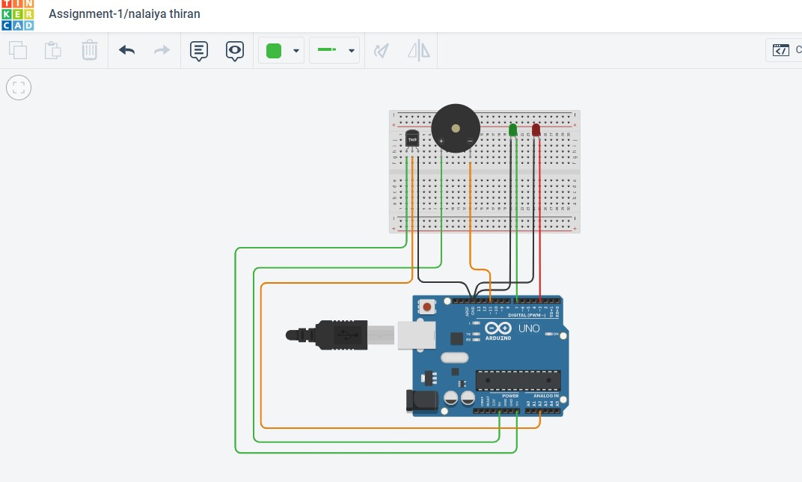

**CODING:**

int ledRed = 3; int ledGreen = 7; int buzzer = 11; int LM35 = 2; void setup()

{

pinMode(LM35, INPUT);

pinMode(ledRed, OUTPUT); pinMode(ledGreen, OUTPUT); pinMode(buzzer, OUTPUT);

Serial.begin(9600);

}

void loop()

{

int value = analogRead(LM35); int temp = value * 0.48; Serial.println(temp); if(temp < 20) { digitalWrite(ledGreen, HIGH); digitalWrite(ledRed, LOW); noTone(buzzer);

} else { digitalWrite(ledRed, HIGH); digitalWrite(ledGreen, LOW); tone(buzzer, 400);

}

}